Weekly Letter 13
English 1 – Beery
November 7-11
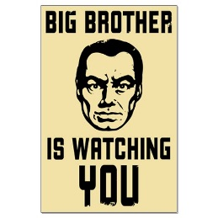

Dystopias have become staples of YA (Young Adult) literature – The Hunger Games is the latest hit in this genre – but 1984 was one of the originals and is still considered one of the best books of the 20th century. As you may know, words that have the prefix “dis” or “dys” are to be seen in a negative light: a dysfunctional family, equipment that has fallen into disuse, or a constitution marred by a serious disease. Dystopias in fiction are the opposite of utopias (a word coined by the famous Christian philosopher and sometime advisor to King Henry VIII, Thomas More, literally meaning “no place”). They usually depict a future in which a problem from the present is expanded and takes over society, and they can be pretty depressing. When Orwell wrote this novel, he was suffering from the tuberculosis that would lead to his death within months of the book’s publication.

The authority figures in 1984 are mostly untrustworthy, and there is no authority other than the legitimate authority. And yet Ingsoc, or English Socialism, is not as simple and two-dimensional as it may seem at first. While you read, notice the lengths to which The Party must go to eliminate, or at least control, normal human interaction, thoughtfulness and trust. Even if Orwell was clearly wrong about when human beings would become so isolated from each other, can you see signs of some of his dystopian vision creeping into 21st century society?
Learning Goals:
- I can read closely and find answers explicitly in text and answers that require an inference
- I can thoroughly support both explicit and inferential questions by analyzing an author’s words and determining multiple pieces of textual evidence that strongly support those questions.
- I can determine how specific details in the text reveal and continually refine a theme.
- I can analyze how complex characters develop over the course of the grade-appropriate text, interact with other characters, and advance the plot of a text or develop the theme.
- I can analyze how specific word choices build upon one another to create a cumulative impact on the overall meaning and tone of a text (i.e., denotative, connotative, figurative)
- I can analyze substantive topics or texts to compare information
- I can determine the credibility of a source and the accuracy of the details presented in the source.
- I can analyze the context of various texts and determine how language choice affects meaning, style, and comprehension.

Core Questions for Quarter 2 & 1984:
As consumers of information, who do I believe?
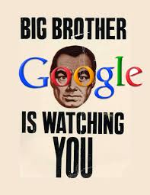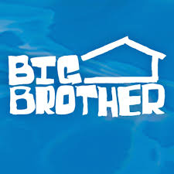

Continue to read and compare this week and be ready to prepare for your next expository/comparison essay this quarter. Be sure to extract strong text evidence and the page numbers from your text to help you in this journey.

M: Weekly Letter:
Distribute Study Guide book II-III
Silent Reading: book 2 chapter 3-6 by Wednesday & SG

T: NO School: PD Day

W: Diction & Tone-- I can analyze how specific word choices build upon one another to create a cumulative impact on the overall meaning and tone of a text (i.e., denotative, connotative, figurative)
---Distribute diction and tone handout
---PowerPoint on learning goal and diction
HMWK: Read Book II ch 7-9 by Friday ---SG optional (adjust reading chapter 9------179-189 (stop at “But is was also clear…” pp 199-207 (stop at “after the middle of the present century…”, pp 217-218)----so now ch 9 is 22 pages instead of 40 +)

TH: Diction & Tone: Review book I vs. book II--- can analyze how specific word choices build upon one another to create a cumulative impact on the overall meaning and tone of a text (i.e., denotative, connotative, figurative)
HMWK: finish reading chapter 9 with adjusted schedule---SG optional----study for Quiz Book II

F: Quiz over Book II
Read Tiananmen Square articles and compare how this information is similar to 1984----Use TE from article and novel. Handwrite this as an on-demand response.
HMWK: Read Book II ch 10 and Book III ch 1 by Monday

Future Assessments coming up this quarter:
- Summative Test will be Thanksgiving Week. The test will cover:
1984
Cold Read
Diction/Tone
Supporting ideas with text evidence
Compare/Contrast
- Socratic Seminar
- Expository Comparison Essay

